AFRICAN SOLIDARITY CIVIC ORGANISATION NPC (ASCO)
Safeguarding and Complaints Policy
BOARD-APPROVED FINAL DOCUMENTATION
FINAL DOCUMENTATION — BOARD APPROVED; EXECUTION / FILING DETAILS TO BE RECORDED
This document records the Board-approved ASCO governance model and policy position. Legal effectiveness, execution, statutory-register updates and filing or registration requirements must be completed by the authorised persons and recorded in the approval register. The Memorandum of Incorporation remains subject to the Companies Act 71 of 2008 and applicable filing requirements.
DOCUMENT CONTROL
Version: 1.0 | Prepared and Board-approved: 10 September 2026 | Resolution reference: To be entered in the approval register | Effective date: To be recorded where applicable | Next review: To be recorded
1. PURPOSE
ASCO protects children, vulnerable persons, participants, staff, volunteers and communities from abuse, exploitation, harassment, retaliation and avoidable harm.
2. REPORTING
Safeguarding reports may be made to info@africansolidaritycivic.org or +27 76 757 5773. If a report concerns a recipient, it must be escalated to the Chairperson or another Board member through the same official contact channel. Immediate danger should be reported to the appropriate emergency or statutory authority.
3. PRINCIPLES
Survivor-centred response; do no harm; confidentiality on a need-to-know basis; non-retaliation; prompt risk assessment; lawful referral; accessibility; and fair treatment of all parties.
4. PROCEDURE
Receive and record; assess immediate risk; safeguard the affected person; acknowledge where safe; refer to competent authorities where required; investigate or appoint an independent investigator; document decisions; and close with corrective action and learning.
5. CONFLICTS
If a complaint concerns the Executive Director, Chairperson, Board member or reporting-channel owner, it must bypass that person and be escalated to the independent Board contact or external authority.
6. PREVENTION
ASCO shall use appropriate recruitment, induction, training, partner due diligence, consent, supervision, photography and data-protection controls.

Place of approval / execution: 49 Rif Road, Manor Gardens, Durban, KwaZulu-Natal, 4001, South Africa
BOARD APPROVAL SIGNATURES
The following signatures are copied from the signed ASCO documents supplied for this purpose. They record Board approval/acknowledgement in the stated capacities; statutory effectiveness, filing and authority remain subject to the applicable approval and filing process.
CHAIRPERSON / FOUNDER  Ms Busisiwe Makhosi Shandu    Date: 6 September 2026  Signature copied from supplied signed document | DIRECTOR: ICT AND COMMUNICATIONS  Mr Thapelo Nelson Maqalika  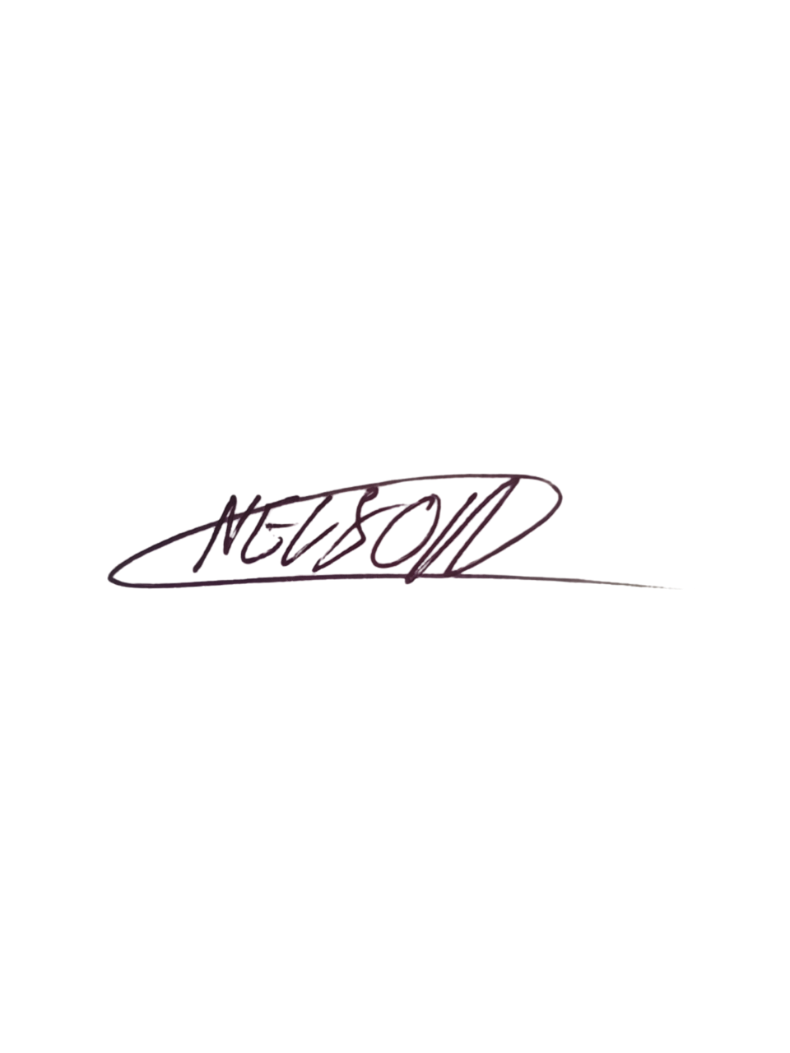  Date: 6 September 2026  Signature copied from supplied signed document
EXECUTIVE DIRECTOR  Mr Bhekisisa Shandu  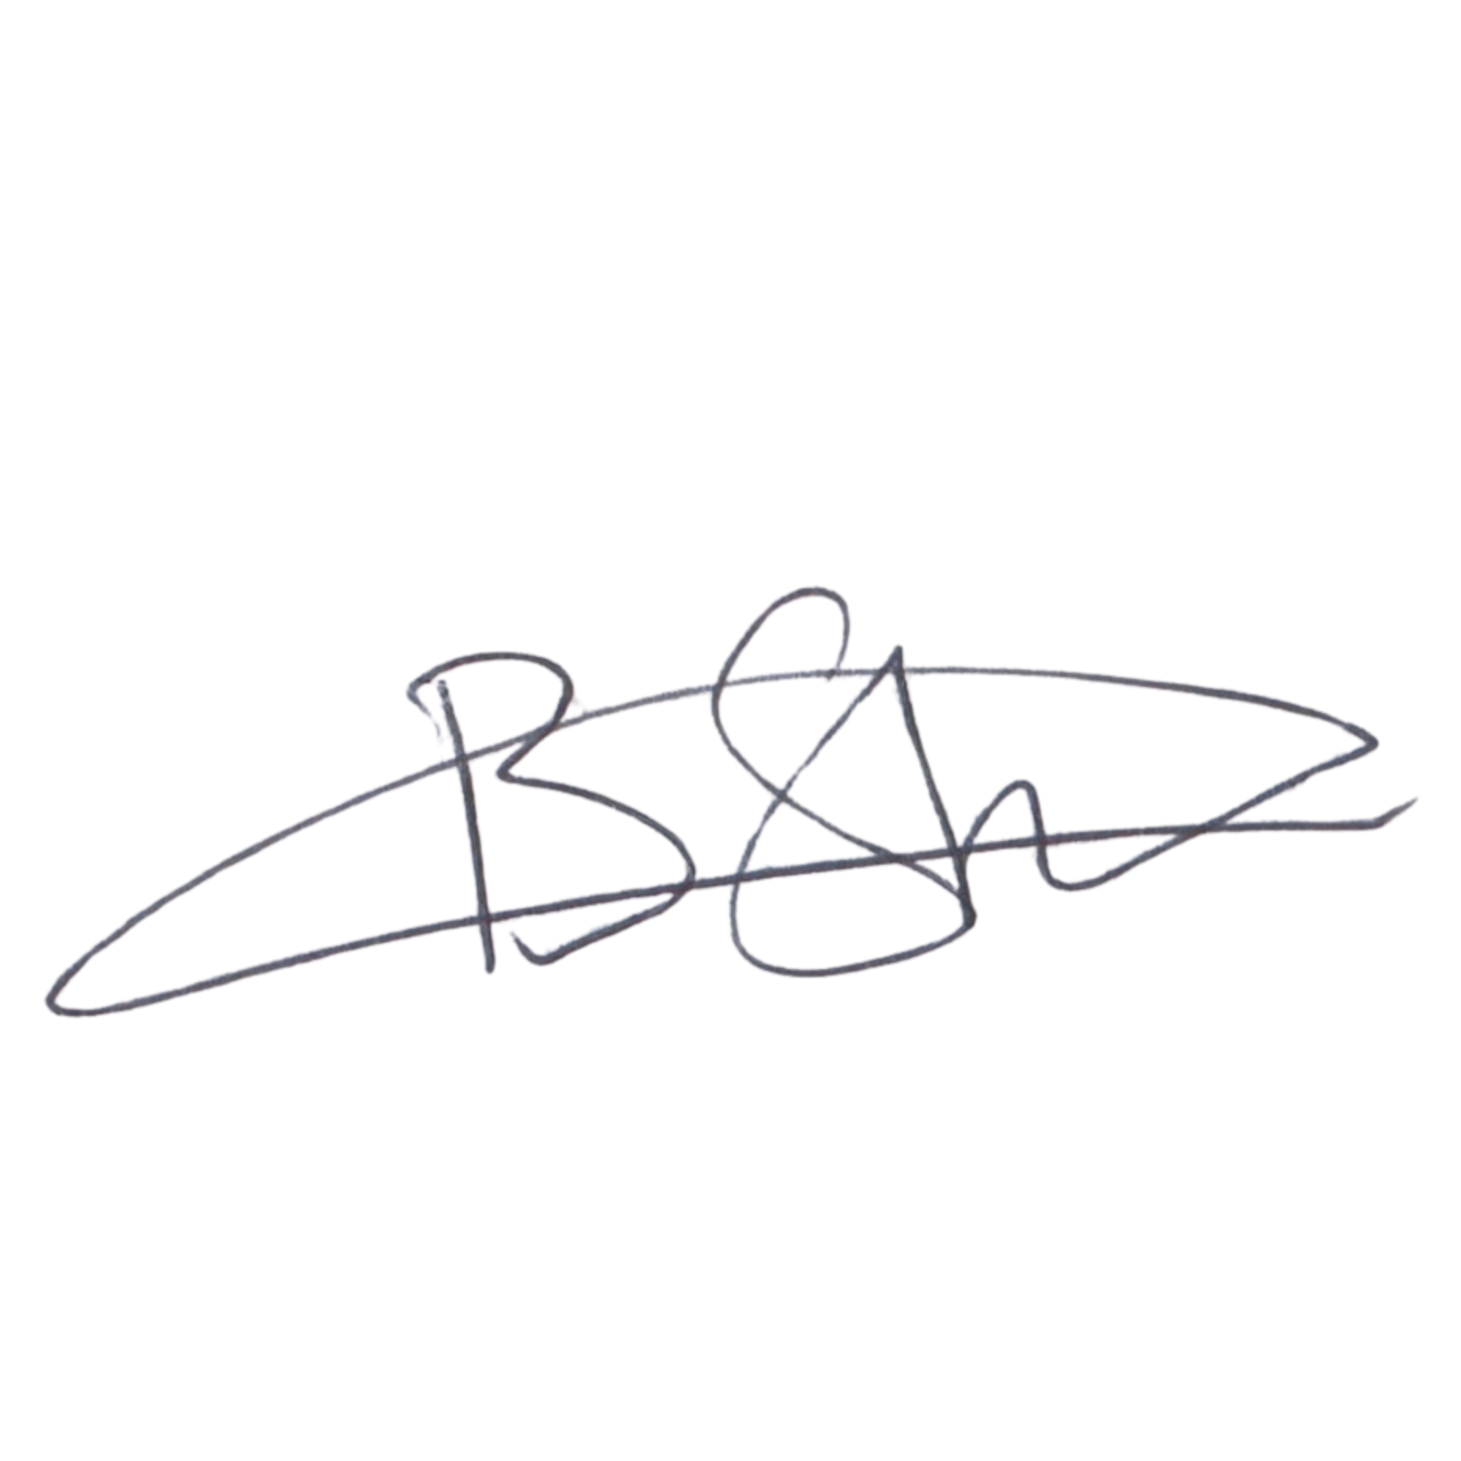  Date: 6 September 2026  Signature copied from supplied signed document | DIRECTOR: PEOPLE AND CULTURE / FINANCE AND PROCUREMENT  Mr Khulekani Gumede  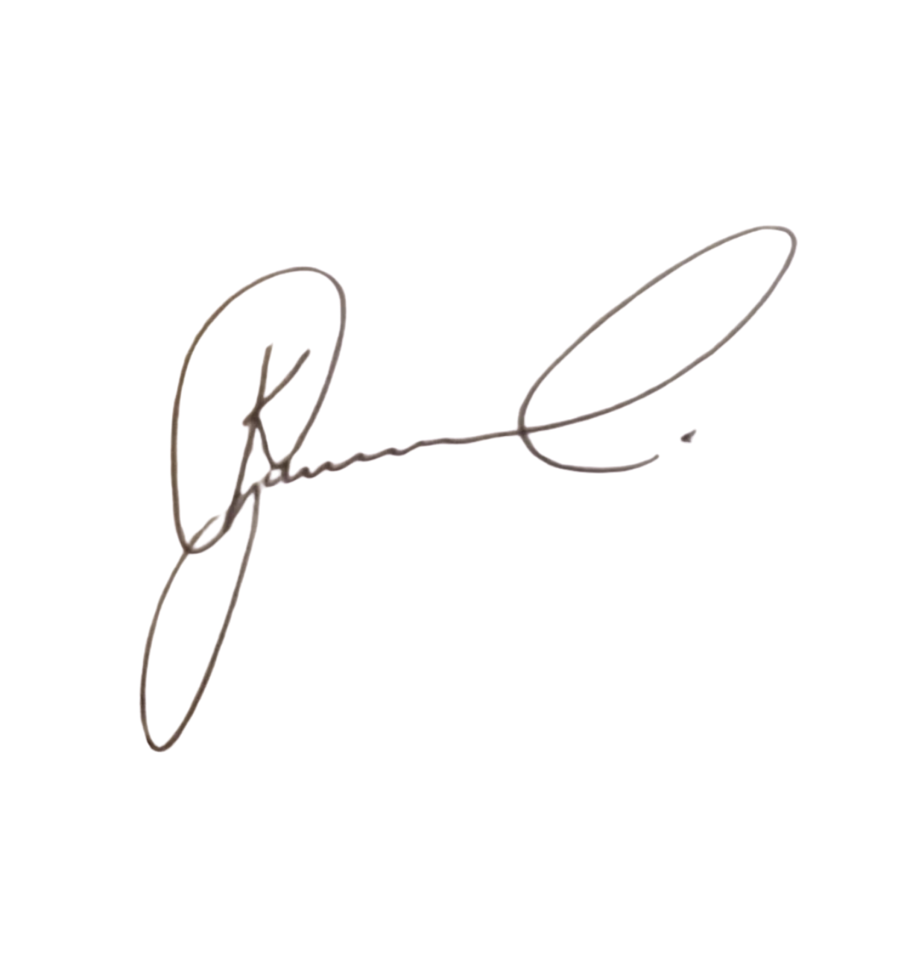  Date: 6 September 2026  Signature copied from supplied signed document

